# Self Assessment Monolith API Migration Plan

Author: Toby Porter | Date: 31 Jul 2020 Version: Draft 0.1

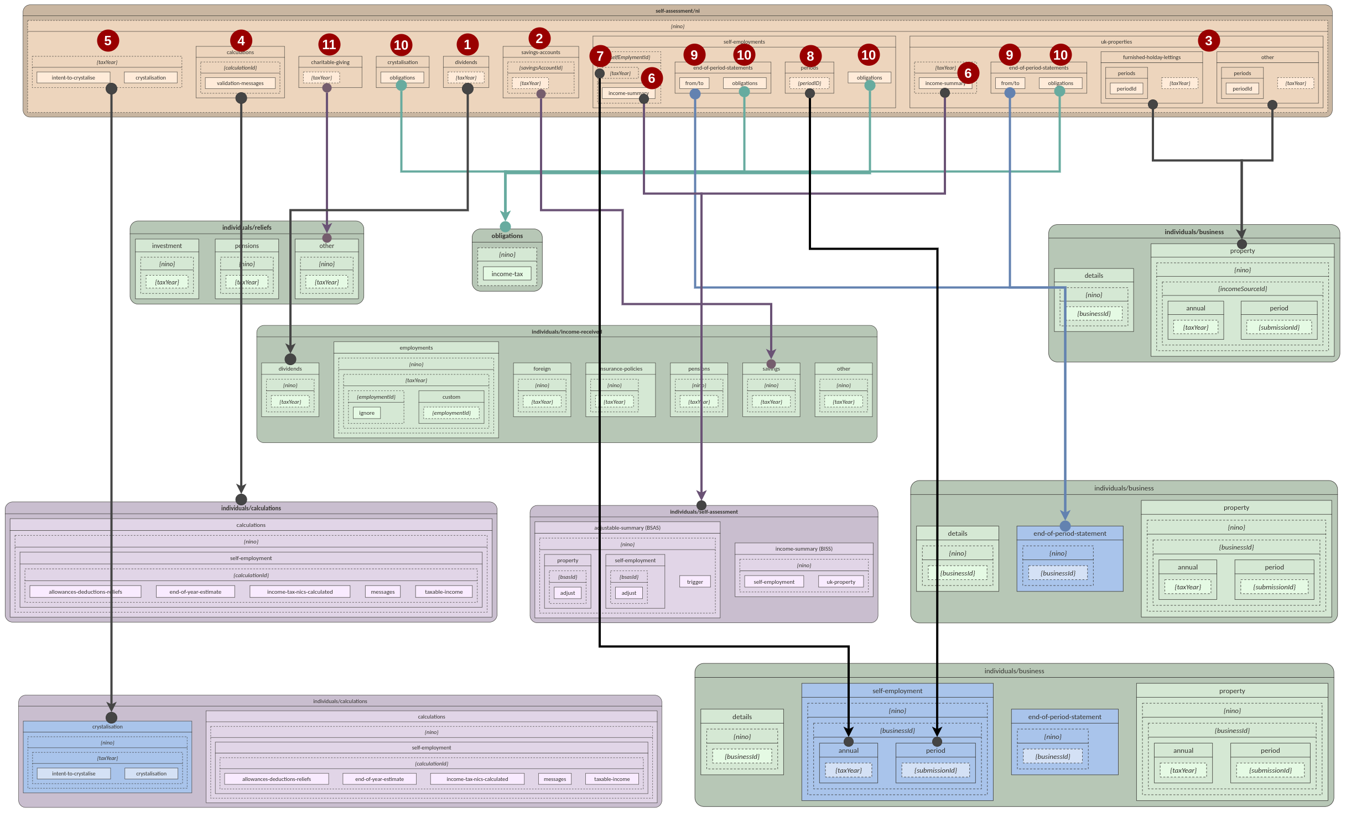

## High Level Migration Plan Summary

Monolith basepath: self-assessment/ni/{nino}

|  |  |  |  |
| --- | --- | --- | --- |
| **Domain** | **Source Endpoint(s)** | **MTD**  **Status** | **Destination Endpoint(s)** |
| **1. Dividends** | ●dividends/{taxYear} | P | ●/individuals/income-received/dividends/{nino}/{taxYear} |
| **2. Savings** | ●savings-accounts/{savingsAccountId}/{taxYear} | P | ●/individuals/income-received/savings/{nino}/{taxYear} |
| **3. Property**  **(UK Annual)** | ●uk-properties/other/{taxYear}  ●uk-properties/furnished-holiday-lettings/{taxYear} | P | ●/individuals/business/property/{nino}/{businessId}/annual/{taxYear} |
| **Property**  **(UK Periodic)** | ●uk-properties/other/periods  ●uk-properties/furnished-holiday-lettings/periods | P | ●/individuals/business/property/{nino}/{businessId}/period/ |
| **4. Calculations** | ●calculations | L | ●/individuals/calculations/{nino}/self-employment |
| **5. Crystalisation** | ●{taxYear}/intent-to-crystalise  ●{taxYear}/crystalisation | P | ●/individuals/calculations/crystalisation/{nino}/{taxYear}/intent-to-crystalise  ●/individuals/calculations/crystalisation/{nino}/{taxYear}/crystalisation |
| **6. SE Income Summary** | ●self-employments/{selfEmploymentId}/{taxYear}/income-summary  ●uk-properties/{selfEmploymentId}/{taxYear}/income-summary | L | ●/individuals/self-assessment/income-summary/{nino}/self-employment  ●/individuals/self-assessment/income-summary/{nino}/uk-property |
| **7. SE Income (Annual)** | ●self-employments/{taxYear} | P | ●individuals/business/self-employment/{nino}/{businessId}/annual/{taxYear} |
| **8. SE Income (Periodic)** | ●self-employments/periods | P | ●individuals/business/self-employment/{nino}/{businessId}/period/ |
| **9. EOPs** | ●self-employments/end-of-period-statements  ●uk-properties/end-of-period-statements | P | ●/individuals/business/end-of-period-statement/{nino}/{businessId} |
| **10. Obligations** | ●crystalisation/obligations  ●self-employments/{selfEmploymentId}/end-of-period-statements/obligations  ●self-employments/obligations  ●uk-properties/end-of-period-statements/obligations | D | ●/obligations/{nino}/income-tax |
| **11. Charitable Giving** | charitable-giving/{taxYear} | P | ●/individuals/reliefs/other/{nino}/{taxYear} |

Status: P = Proposed; L = Live; D = In development

## 

## 

## High Level Migration Impact Summary

|  |  |  |  |  |  |  |  |
| --- | --- | --- | --- | --- | --- | --- | --- |
| **Domain** | **Migration Strategy** | **3PV** | **MTD API** | **DES** | **ITSD** | **IBD** | **ETMP** |
| **1. Dividends** | Upgrade & re-version | Advise to use new service | Amend request to DES and  a) maintain same contact  or  b) agree a new contact | a) None  or  b) amend request to ITSD | None* | None* | None |
| **2. Savings** | Upgrade & re-version | Advise to use new service | Amend request to DES and  a) maintain same contact  or  b) agree a new contact | a) None  or  b) amend request to ITSD | None* | None* | None |
| **3. Property (UK Annual)** | Upgrade & re-version | Advise to use new service | Amend request to DES and  a) maintain same contact  or  b) agree a new contact | a) None  or  b) amend request to ITSD | None* | None* | None |
| **Property (UK Periodic)** | Upgrade & re-version | Advise to use new service | Amend request to DES and  a) maintain same contact  or  b) agree a new contact | a) None  or  b) amend request to ITSD | None* | None* | None |
| **4. Calculations** | Lift & shift | Already advised to use new service | None | None | None | None | None |
| **5. Crystalisation** | Lift & shift | Advise to use new service | Register new service with API Platform | None | None | None | None |
| **6. SE Income Summary** | Lift & shift | Already advised to use new service | None | None | None | None | None |
| **7. SE Income (Annual)** | Lift & shift | Advise to use new service | Register new service with API Platform | None | None | None | None |
| **8. SE Income (Periodic)** | Lift & shift | Advise to use new service | Register new service with API Platform | None | None | None | None |
| **9. EOPs** | Lift & shift | Advise to use new service | None  (already in development) | None | None | None | None |
| **10. Obligations** | Lift & shift | Advise to use new service | None  (already in development) | None | None | None | None |
| **11. Charitable Giving** | Upgrade & reversion | Advise to use new service | Amend request to DES and  a) maintain same contact  or  b) agree a new contact | a) None  or  b) amend request to ITSD | None* | None* | None |

* Assumes no downstream impact if MTD API or DES perform the transformation.

# 

# Migration Details

### Dividends

**Endpoints**

|  |  |  |  |
| --- | --- | --- | --- |
| **Source Path(s)**  /self-assessment/ni/{nino} | **Src. Method** | **Destination Path(s)** | **Dest. Method** |
| /dividends/{taxYear} | GET | /individuals/income-received/dividends/{nino}/{taxYear} | GET |
| /dividends/{taxYear} | PUT | /individuals/income-received/dividends/{nino}/{taxYear} | PUT |
|  |  | /individuals/income-received/dividends/{nino}/{taxYear} | DELETE |

**Request/Response**

|  |  |
| --- | --- |
| **Example Source Request** | **Example Destination Request** |
| {  "ukDividends": 1000.50,  "otherUkDividends": 2000.35  } | {  "foreignDividend": [  {  "countryCode": "GER",  "amountBeforeTax": 1232.22,  "taxTakenOff": 22.22,  "specialWitholdingTax": 22.22,  "foreignTaxCreditRelief": true,  "taxableAmount": 2321.22  }  ],  "dividendIncomeReceivedWhilstAbroad": [  {  "countryCode": "GER",  "amountBeforeTax": 1232.22,  "taxTakenOff": 22.22,  "specialWitholdingTax": 22.22,  "foreignTaxCreditRelief": true,  "taxableAmount": 2321.22  }  ],  "stockDividend": {  "customerReference": "my divs",  "grossAmount": 12321.22  },  "redeemableShares": {  "customerReference": "my shares",  "grossAmount": 12321.22  },  "bonusIssuesOfSecurities": {  "customerReference": "my secs",  "grossAmount": 12321.22  },  "closeCompanyLoansWrittenOff": {  "customerReference": "write off",  "grossAmount": 12321.22  },  "ukDividends": {  "grossAmount": 1000.50  },  "otherUkDividends" {  "grossAmount": 2000.35  }  } |

**End to End Impact**

|  |  |
| --- | --- |
| **System** |  |
| DES |  |
| ITSD |  |
| IBD |  |
| ETMP |  |

### Savings

**Endpoints**

|  |  |  |  |
| --- | --- | --- | --- |
| **Source Path(s)**  /self-assessment/ni/{nino} | **Src. Method** | **Destination Path(s)** | **Dest. Method** |
| /savings-accounts | POST | /individuals/income-received/savings/{nino}/{taxYear} | PUT |
| /savings-accounts | GET | /individuals/income-received/savings/{nino}/{taxYear} | GET |
| /savings-accounts/{savingsAccountId} | GET | /individuals/income-received/savings/{nino}/{taxYear} | GET |
| /savings-accounts/{savingsAccountId}/{taxYear} | GET | /individuals/income-received/savings/{nino}/{taxYear} | GET |
| /savings-accounts/{savingsAccountId}/{taxYear} | PUT | /individuals/income-received/savings/{nino}/{taxYear} | PUT |
|  |  | /individuals/income-received/savings/{nino}/{taxYear} | DELETE |

**Request/Response**

|  |  |
| --- | --- |
| **Example Source Request(s)** | **Example Destination Request(s)** |
| {  "savingsAccounts": [  {  "id": "SAVKB2UVwUTBQGJ",  "accountName": "Main Savings Account"  },  {  "id": "SAVKB2UVwUTBQGK",  "accountName": "Holiday Savings"  }  ]  }  {  "taxedUkInterest": 1230.55,  "untaxedUkInterest": 500.5  } | {  "securities":  {  "taxTakenOff": 100.0,  "grossAmount": 1455.0,  "netAmount": 123.22  },  "foreignInterest": [  {  "amountBeforeTax": 1232.22,  "countryCode": "GER",  "taxTakenOff": 22.22,  "specialWitholdingTax": 22.22,  "taxableAmount": 2321.22,  "foreignTaxCreditRelief": true  }  ],  "UkSavingsAccounts": [  { customerReference": "Main Savings Account,  "taxTakenOff": 100.0,  "grossAmount": 1455.0,  "netAmount": 123.22  },  { customerReference": "Holiday Savings",  "taxTakenOff": 100.0,  "grossAmount": 1455.0,  "netAmount": 123.22  }  ]  } |
|  |  |

**End to End Considerations**

**DES**

**ITSD**

**ETMP**

**IBD**

### Property (UK Annual)

**Endpoints**

|  |  |  |  |
| --- | --- | --- | --- |
| **Source Path(s)**  /self-assessment/ni/{nino} | **Src. Method** | **Destination Path(s)** | **Dest. Method** |
| uk-properties/other/{taxYear} | GET | /individuals/business/property/{nino}/{businessId}/annual/{taxYear} | GET |
| uk-properties/other/{taxYear} | PUT | /individuals/business/property/{nino}/{businessId}/annual/{taxYear} | PUT |
| uk-properties/furnished-holiday-lettings/{taxYear} | GET | /individuals/business/property/{nino}/{businessId}/annual/{taxYear} | GET |
| uk-properties/furnished-holiday-lettings/{taxYear} | PUT | /individuals/business/property/{nino}/{businessId}/annual/{taxYear} | PUT |
|  |  | individuals/business/property/{nino}/{businessId}/annual/{taxYear} | DELETE |

**Request/Response**

|  |  |
| --- | --- |
| **Example Source Request(s)** | **Example Destination Request(s)** |
| {  "adjustments": {  "lossBroughtForward": 100.25,  "privateUseAdjustment": 100.25,  "balancingCharge": 100.25,  "bpraBalancingCharge": 100.25  },  "allowances": {  "annualInvestmentAllowance": 100.25,  "costOfReplacingDomesticItems": 100.25,  "zeroEmissionsGoodsVehicleAllowance": 100.25,  "businessPremisesRenovationAllowance": 100.25,  "propertyAllowance": 100.25,  "otherCapitalAllowance": 100.25  },  "other": {  "nonResidentLandlord": false,  "rarJointLet": true  }  } | {  "foreignFhlEea" :{  "adjustments": {  "privateUseAdjustment": 100.25,  "balancingCharge": 100.25,  "periodOfGraceAdjustment": true  },  "allowances": {  "annualInvestmentAllowance": 100.25,  "otherCapitalAllowance": 100.25,  "propertyAllowance": 100.25,  "electricChargePointAllowance": 100.25  }  },  "foreignProperty": [  {  "countryCode": "GER",  "adjustments": {  "privateUseAdjustment": 100.25,  "balancingCharge": 100.25  },  "allowances": {  "annualInvestmentAllowance": 100.25,  "costOfReplacingDomesticItems": 100.25,  "zeroEmissionsGoodsVehicleAllowance": 100.25,  "propertyAllowance": 100.25,  "otherCapitalAllowance": 100.25,  "structureAndBuildingAllowance": 100.25,  "electricChargePointAllowance": 100.25  }  }  ]  "UkOther": [  {  "adjustments": {  "lossBroughtForward": 100.25,  "privateUseAdjustment": 100.25,  "balancingCharge": 100.25,  "bpraBalancingCharge": 100.25  },  "allowances": {  "annualInvestmentAllowance": 100.25,  "costOfReplacingDomesticItems": 100.25,  "zeroEmissionsGoodsVehicleAllowance": 100.25,  "businessPremisesRenovationAllowance": 100.25,  "propertyAllowance": 100.25,  "otherCapitalAllowance": 100.25,  }  "otherInformation": {  "nonResidentLandlord": false,  "rarJointLet": true  }  }  ],  "UkFurnishedHolidayLet": [  {  "adjustments": {  "lossBroughtForward": 100.25,  "privateUseAdjustment": 100.25,  "balancingCharge": 100.25,  "bpraBalancingCharge": 100.25  },  "allowances": {  "annualInvestmentAllowance": 100.25,  "costOfReplacingDomesticItems": 100.25,  "zeroEmissionsGoodsVehicleAllowance": 100.25,  "businessPremisesRenovationAllowance": 100.25,  "propertyAllowance": 100.25,  "otherCapitalAllowance": 100.25,  }  "otherInformation": {  "nonResidentLandlord": false,  "rarJointLet": true  }  }  ]  } |
|  |  |

**Transformation**

Issue - Will need to default a businessId or make optional (in the short term)

**End to End Considerations**

**DES**

**ITSD**

**ETMP**

**IBD**

### Property (UK Periodic)

### Calculations

### Crystalisation

**Endpoints**

|  |  |  |  |
| --- | --- | --- | --- |
| **Source Path(s)**  /self-assessment/ni/{nino} | **Src. Method** | **Destination Path(s)** | **Dest. Method** |
| /{taxYear}/intent-to-crystalise | POST | /individuals/calculations/crystalisation/{nino}/{taxYear}/intent-to-crystalise | POST |
| /{taxYear}/crystalisation | POST | /individuals/calculations/crystalisation/{nino}/{taxYear}/crystalisation | POST |

**Request/Response**

|  |  |
| --- | --- |
| **Example Source Request** | **Example Destination Request** |
| {  "calculationId": "041f7e4d-87b9-4d4a-a296-3cfbdf92f7e2"  } | {  "calculationId": "041f7e4d-87b9-4d4a-a296-3cfbdf92f7e2"  } |

**End to End Impact**

|  |  |
| --- | --- |
| **System** |  |
| DES |  |
| ITSD |  |
| IBD |  |
| ETMP |  |

### Income Summary

### Income (Annual)

### Income (Periodic)

### EOPs

### Obligations

### Charitable Giving

**Endpoints**

|  |  |  |  |
| --- | --- | --- | --- |
| **Source Path(s)**  /self-assessment/ni/{nino} | **Src. Method** | **Destination Path(s)** | **Dest. Method** |
| charitable-giving/{taxYear} | GET | /individuals/reliefs/other/{nino}/{taxYear} | GET |
| charitable-giving/{taxYear} | PUT | /individuals/reliefs/other/{nino}/{taxYear} | PUT |
|  |  | /individuals/reliefs/other/{nino}/{taxYear} | DELETE |

**Request/Response**

|  |  |
| --- | --- |
| **Example Source Request** | **Example Destination Request** |
| {  "giftAidPayments": {  "specifiedYear": 10000.50,  "oneOffSpecifiedYear": 1000.00,  "specifiedYearTreatedAsPreviousYear": 300.00,  "followingYearTreatedAsSpecifiedYear": 400.00,  "nonUKCharities": 2000.00,  "nonUKCharityNames": [  "International Charity A",  "International Charity B"  ]  },  "gifts": {  "sharesOrSecurities": 600.00,  "landAndBuildings": 700.35,  "investmentsNonUKCharities": 300.00,  "investmentsNonUKCharityNames": [  "International Charity C",  "International Charity D"  ]  }  } | {  "nonDeductableLoanInterest": {  "customerReference": "myref",  "reliefClaimed": 763.00  },  "payrollGiving": {  "customerReference": "myref",  "reliefClaimed": 154.00  },  "qualifyingDistributionRedemptionOfSharesAndSecurities": {  "customerReference": "myref",  "amount": 222.22  },  "maintenancePayments": [  {  "customerReference": "myref",  "exSpouseName" : "Hilda",  "exSpouseDateOfBirth": "2000-01-01",  "amount": 222.22  }  ],  "postCessationTradeReliefAndCertainOtherLosses": [  {  "customerReference": "myref",  "businessName": "ACME Inc",  "dateBusinessCeased": "2019-08-10",  "natureOfTrade": "Widgets Manufacturer",  "incomeSource": "AB12412/A12",  "amount": 222.22  }  ],  "annualPaymentsMade": {  "customerReference": "myref",  "reliefClaimed": 763.00  },  "qualifyingLoanInterestPayments": [  {  "customerReference": "myref",  "lenderName": "Maurice",  "reliefClaimed": 763.00  }  ],  "giftAidPayments": {  "specifiedYear": 10000.50,  "oneOffSpecifiedYear": 1000.00,  "specifiedYearTreatedAsPreviousYear": 300.00,  "followingYearTreatedAsSpecifiedYear": 400.00,  "nonUKCharities": 2000.00,  "nonUKCharityNames": [  "International Charity A",  "International Charity B"  ]  },  "gifts": {  "sharesOrSecurities": 600.00,  "landAndBuildings": 700.35,  "investmentsNonUKCharities": 300.00,  "investmentsNonUKCharityNames": [  "International Charity C",  "International Charity D"  ]  }  } |

**End to End**

**DES**

**ITSD**

**ETMP**

**IBD**

## Issues

* No EOPs for foreign property
* Business ID not currently mandatory for UK property
* TXM Implications